

**06**

**Design of each form in the** **application ….**

**Login page**

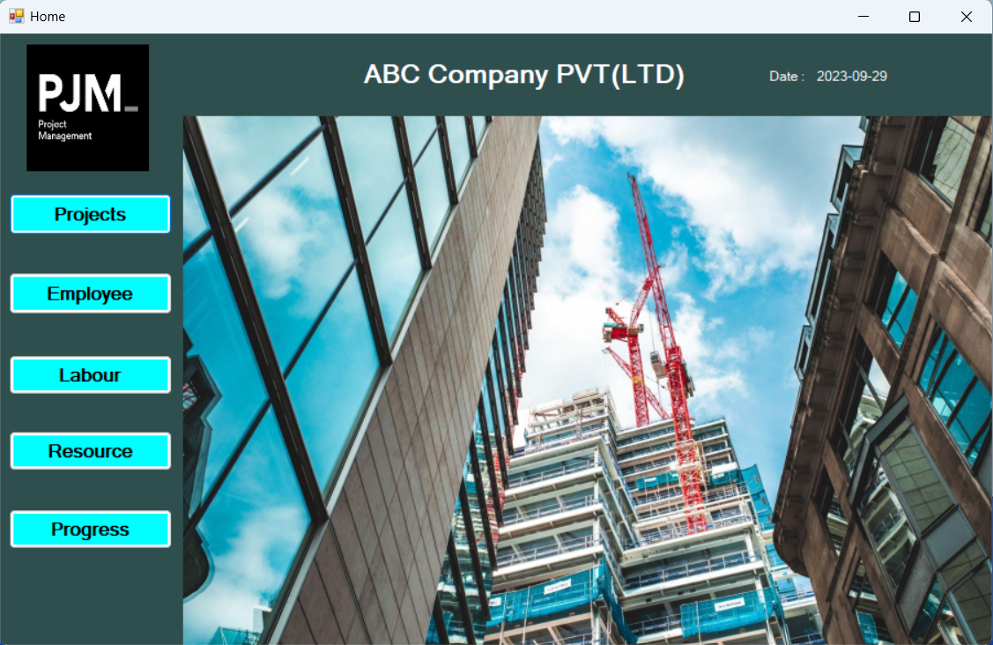

**Dashboard**

**Project page**

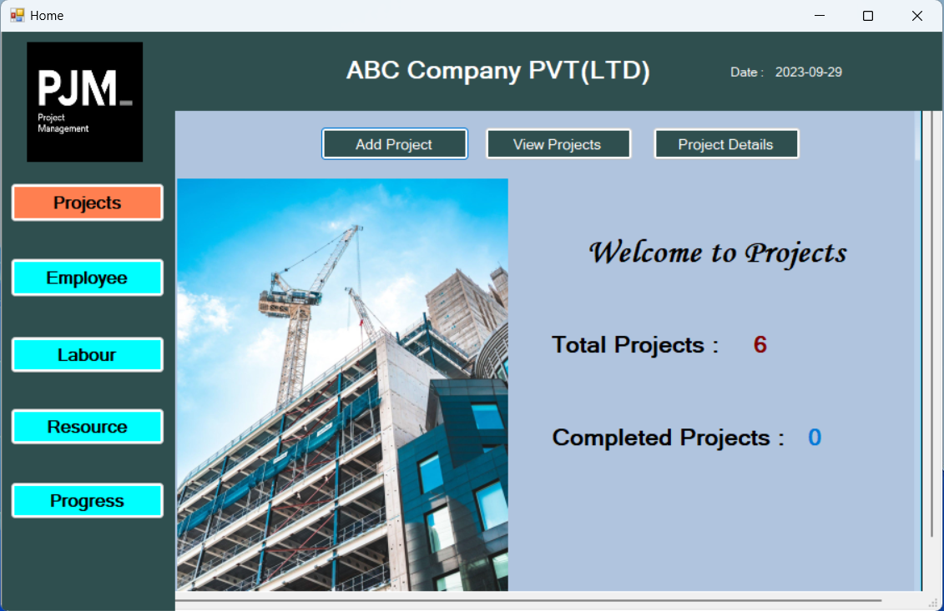

**Add new project.**

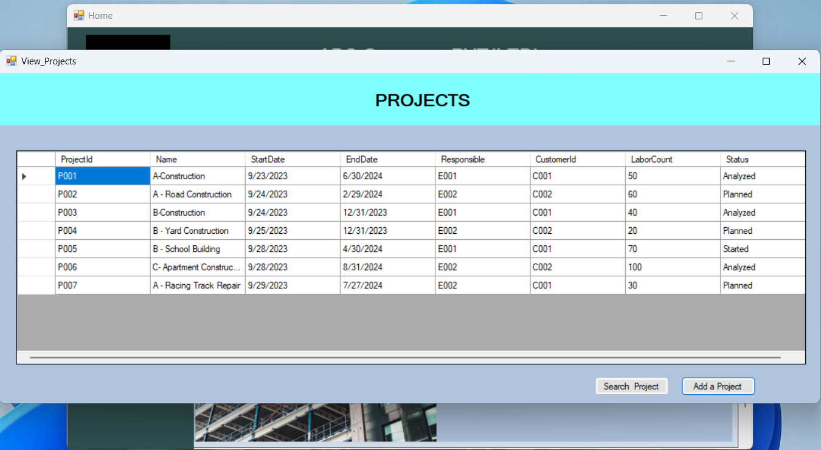

**View all project**

**View single project details.**

**Project page**

**Add new employee.**

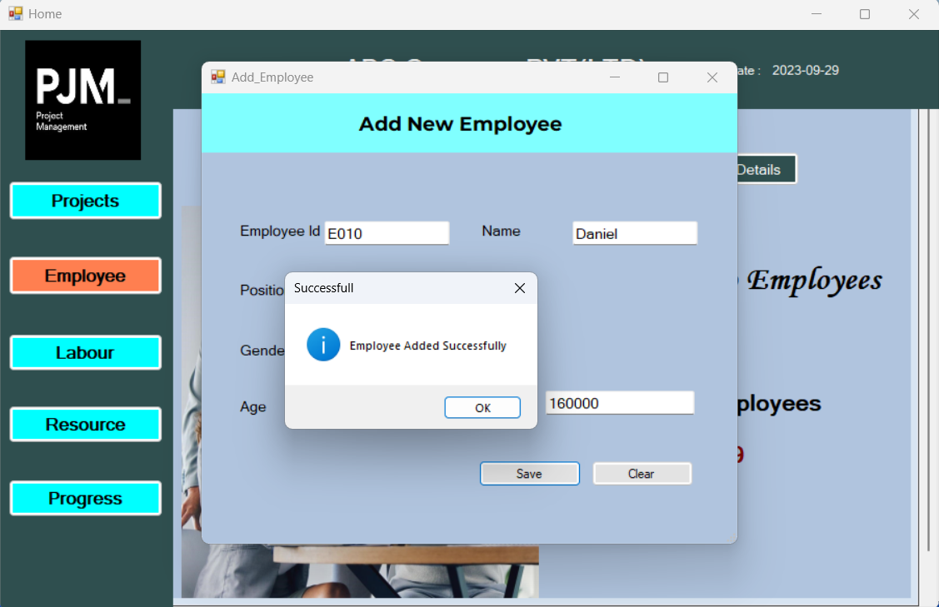

**View all employees**

**View single employee details.**

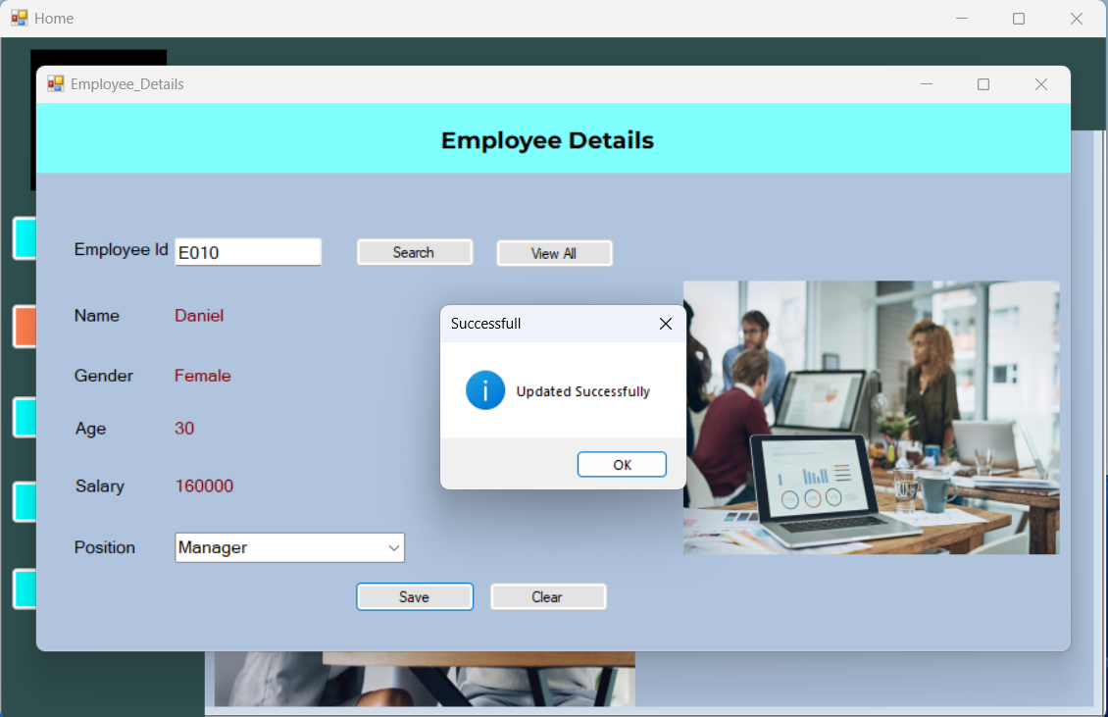

**Labour page**

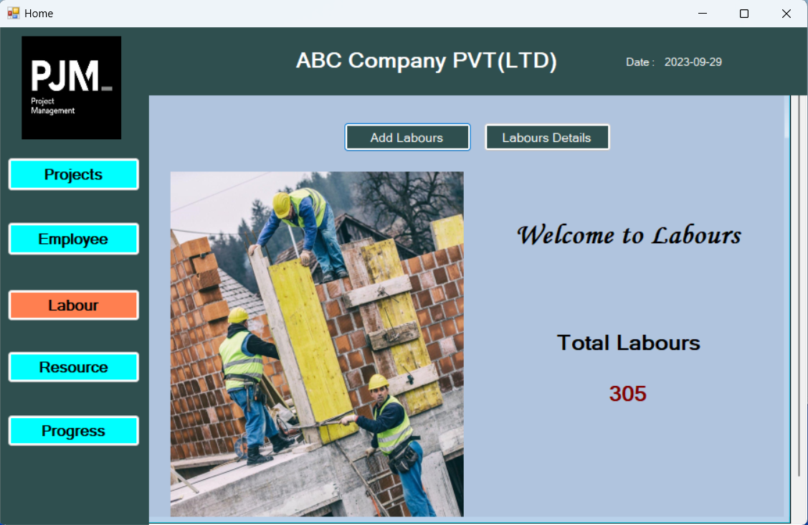

**Add new labour.**

**View all labours details**

